## 3.4 Requirements Engineering

Requirements engineering is a process in which one finds out, analyses, document and check the services and constraints that are going to be provided by the system. Usually carried out after a solution has been proposed. The requirements are usually collected from potential users. Then later on organized and specified in a document.

In this case, the requirements were collected from the FYPs coordinator. The data collection method that was used is mainly interview, which was conducted in form of an open interview with one main question which was also open-ended. What would you like the FYP Web Portal to do for you? The other method that we used was ethnography, with this the observation was carried out by the development team itself since it is part of the college community.

*Figure:*

Next, the unstructured gathered data is classified and organized into groups of related requirements and consistent. The organized requirements are then used to develop the architectural design of the system. In this stage the actors of the system are identified and the functional and non-functional requirement of the system were documented.

The system has four actors who are:

* Student
* Supervisor
* Coordinator
* System

### Functional Requirements

Depending on the user the following are the functional requirements of the system

1. Student
2. A student shall be able to login into the system using an ID and password.
3. A student shall be able to suggest a project title
4. A student shall be able to write a concept note and submit it
5. A student shall be able to choose whether they are doing individual or group projects.
6. A student shall be able to suggest group members
7. A student shall be able to submit/save their progress reports
8. A student shall be able to communicate with their supervisor using messages
9. A student shall be able to view past project titles.
10. A student shall be able to view announcements posted by the coordinator.
11. A student shall be able to view the list of all available supervisors and their areas of expertise

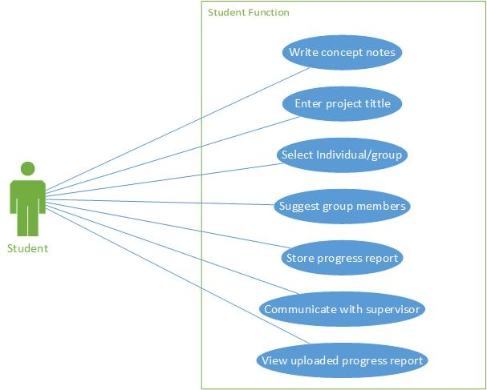

1. Project Coordinator
2. The coordinator shall be able to login with a user name and unique ID
3. The coordinator shall be able to register students
4. The coordinator shall be able to register professors and their areas of expertise
5. The coordinator shall be able to edit groups suggested by students
6. The coordinator shall be able to allocate supervisors to students and groups
7. The coordinator shall be able to post announcements
8. The coordinator shall be able to view the concept notes submitted by student
9. The coordinator shall be able to view progress reports submitted by students
10. The coordinator shall be able to communicate with students

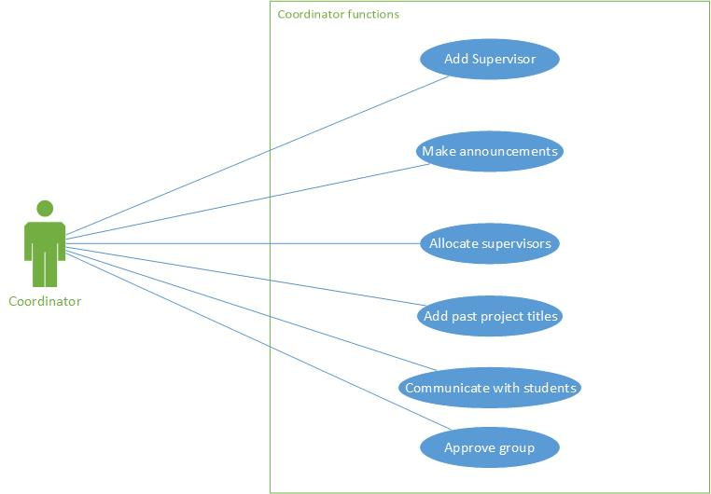

1. Supervisor
2. A supervisor shall be able to view students assigned to him/her

A supervisor should be able to see a list of all students and/or groups s/he is supervising. The list should contain students’ details and project titles.

1. A supervisor shall be able to approve concept notes submitted under his name

In this case a supervisor will be able to choose one of the available options that indicate whether or not an application passed evaluation or not. The options are approved, need improvement, or rejected.

1. A supervisor shall be able to evaluate/ grade students during presentation
2. A supervisor shall be able to view reports submitted by students
3. A supervisor shall be able to comment on reports submitted by students
4. The system
5. Generate reminders for announcement deadlines
6. The system shall keep track of the number of students that have submitted concept notes to a particular supervisor.
7. The system shall keep of the number of students supervised by a particular supervisor
8. The system shall store gradebooks for each student

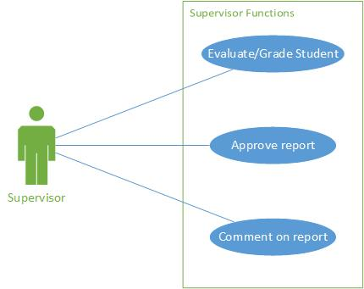

### Database Schema

The proposed database design for the project is shown below:

(We’ll include it tomorrow after the group meeting)